Calibration Summary: La Joie

Basin Info
Location | 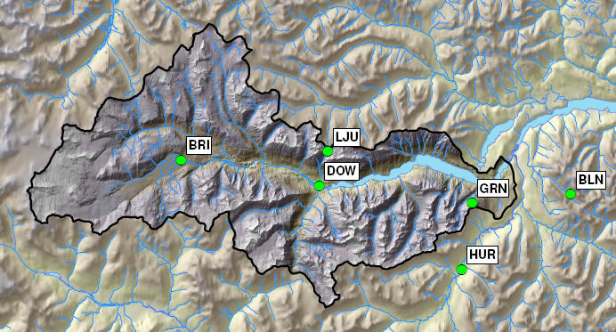
Drainage area | 988.0 km²
Elevation | Min | 717 m |  |  | Max | 2933 m
Glaciated Area | 190.7 km² (19.3%)
Hypsographic Curve | 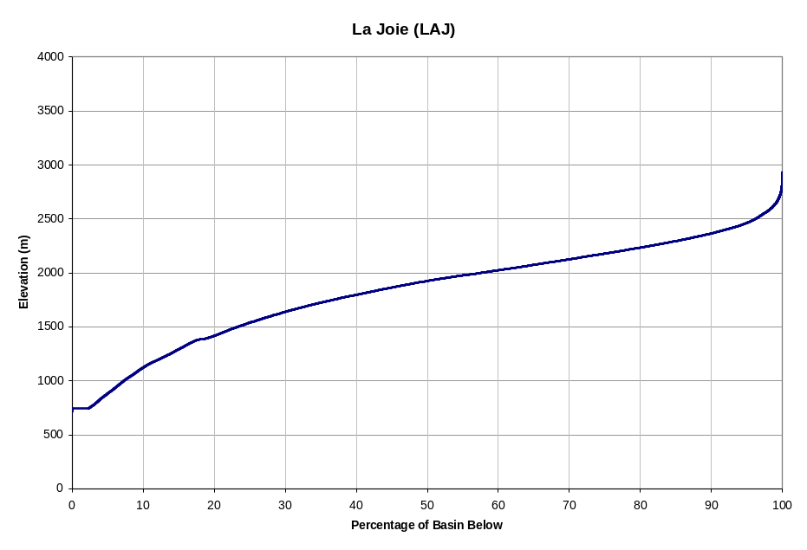
Avg. Annual Precipitation ¹⁾ | 1256 mm (PRISM: 1495 mm) |  |  | Avg. Annual Snowfall ¹⁾ |  |  |  | 963 mm (77% P)
Avg. Annual Runoff | 1401 mm (44 m³/s ; 112% P) |  |  | Avg. Glaciermelt Runoff ¹⁾ |  |  |  | 350 mm (25.0% Q)
Avg. Annual Hydrograph / Hyetograph | 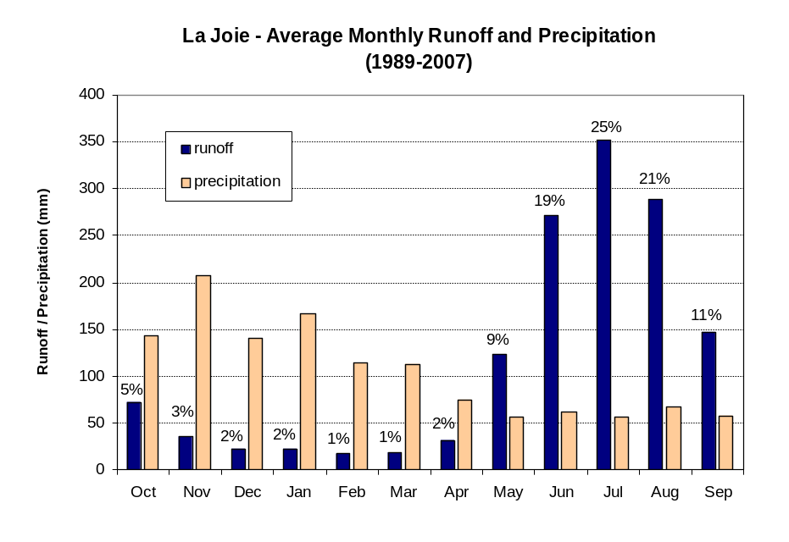
Normal Runoff (1971-2000) | Month |  | Inflow (cms) |  |  |  | Inflow (10⁶ m³)
Normal Runoff (1971-2000) | Jan |  | 6.6 |  |  |  | 17.8
Normal Runoff (1971-2000) | Feb |  | 6.0 |  |  |  | 14.5
Normal Runoff (1971-2000) | Mar |  | 6.4 |  |  |  | 17.2
Normal Runoff (1971-2000) | Apr |  | 10.7 |  |  |  | 27.8
Normal Runoff (1971-2000) | May |  | 38.9 |  |  |  | 104.1
Normal Runoff (1971-2000) | Jun |  | 96.6 |  |  |  | 250.3
Normal Runoff (1971-2000) | Jul |  | 121.8 |  |  |  | 326.2
Normal Runoff (1971-2000) | Aug |  | 108.2 |  |  |  | 289.9
Normal Runoff (1971-2000) | Sep |  | 57.1 |  |  |  | 148.0
Normal Runoff (1971-2000) | Oct |  | 24.4 |  |  |  | 65.5
Normal Runoff (1971-2000) | Nov |  | 11.8 |  |  |  | 30.7
Normal Runoff (1971-2000) | Dec |  | 7.4 |  |  |  | 19.9
Runoff Regime | Nival-glacial
Main Tributaries | Bridge River above Downton Lake DCP
Best Reference Stream (R²) | Bridge River above Downton Lake DCP (WSC 08ME028; R2 = 0.98)

Notes 1) Estimated from UBC watershed model

Calibration Info
Calibration Period | 1989-2007
Verification Period | 1984-1989
# of Elevation Bands | 9
Temperature Data  - Band assignment  - Filename  - Composition  - Station 1  - TS ID | [All bands]  LJUOnly.ADC  LJU  La Joie Upper DCP (LJU; 1829 m)  100000.1/102.00/314 (312)
Precipitation Data  - Band assignment  - Filename  - Composition  - Station 1  - TS ID | [All bands]  LJUOnly.ADC  LJU  La Joie Upper DCP (LJU; 1829 m)  100000.1/110.00/315
Flow Data  - TS ID | 100000.1/110.00/315
Parameters  - Filename  - Date | LAJ.wat  Jan 12, 2011
Time Constants  - Fast runoff -rain  - Fast runoff - snowmelt  - Fast runoff - glacier  - Interflow - rain  - Interflow - snowmelt  - Upper groundwater  - Deep groundwater | 0.79 days  1.3 days  1.1 days  3.6 days  4.0 days  22.2 days  170.1 days
Folder Name | J:\PS\pso\Hydrology\UBCWM calibration 2008\results\FINAL\LAJ
Modeler | S. Weston

Best-of-ensemble Parameter Set Performance Statistics
Daily  Nash-Sutcliff | Monthly  % volume error |  |  |  |  |  |  |  |  |  |  |  | Yearly  % volume error
 | Jan | Feb | Mar | Apr | May | Jun | Jul | Aug | Sep | Oct | Nov | Dec
2001 calibration, total period (Oct 1 1986 to Sep 30 1998)
0.84 | 17.8 | 15.1 | 5.5 | -22.0 | -15.8 | -3.3 | 4.6 | -7.3 | -2.9 | 10.0 | 39.8 | 36.6 | 1.5
Absynthe, total period (Oct 1 1984 to Sep 30 2007)
0.87 | 1.2 | -2.5 | 2.9 | -3.3 | 2.2 | -1.6 | 1.8 | -7.6 | -6.1 | -7.2 | 8.8 | 11.8 | -1.4
Absynthe, calibration period (Oct 1 1989 to Sep 30 2007)
0.90 | -4.1 | -8.1 | 5.7 | -1.9 | 7.2 | -0.4 | 0.5 | -6.5 | -3.7 | -2.7 | 5.9 | 9.8 | -0.6
Absynthe, validation period (Oct 1 1984 to Sep 30 1989)
0.76 | 20.0 | 15.4 | -14.8 | -12.9 | -19.8 | -6.5 | 6.9 | -12.1 | -16.3 | -26.0 | 14.7 | 11.0 | -9.7

Comments

Additional Documentation
- J:\PS\pso\Hydrology\UBCWM calibration 2008\results\FINAL\SGR\SGR_Summary of Recalibration Results 3LID.doc
- J:\PS\pso\Hydrology\UBCWM calibration 2008\documents\UBCWM Recalibration Roadmap\ UBCWM_RecalibrationRoadmap_2ndDRAFT_v1.doc
- J:\PS\pso\Hydrology\UBCWM calibration 2008\documents\UBCWM Recalibration Roadmap\ UBCWM_RecalibrationRoadmap_JULY2008-ADDENDUM_v7.doc
- Scott – DMC analysis
- Scott – GIS analysis

Calibration reviewed by: F. Weber
Date: May 19, 2009

